Navigating the Internet and Learning Online

Match the words with the pictures. There is one word you will not need.
breadcrumbs - scroll bar - text box – drop down menu – log in - address bar – search – blocks - QR code - radio buttons - check boxes

  1.________________________________ | 2._______________________________
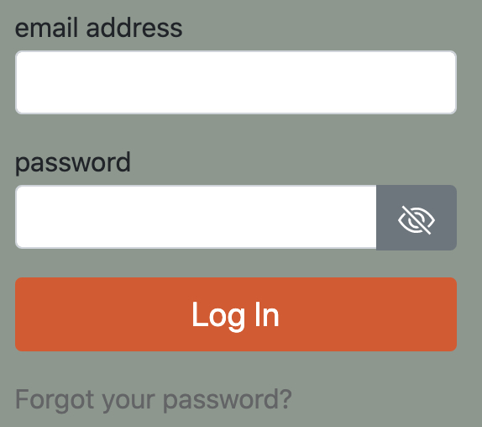  3.________________________________ |   4.________________________________
  5._______________________________ |   6.________________________________
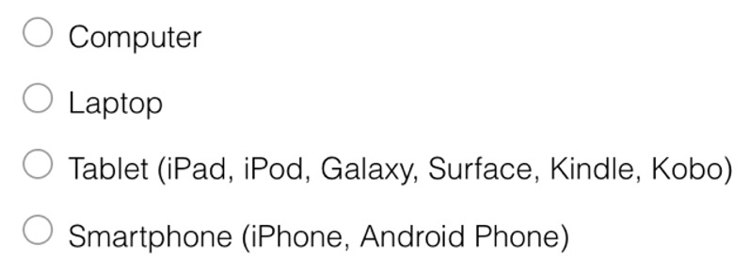  7._______________________________ | 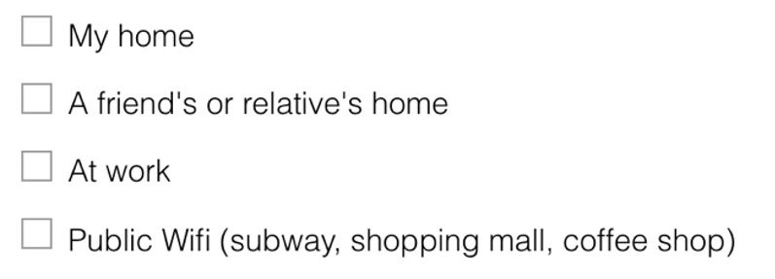  8._______________________________
  9._______________________________ |   10._______________________________

Glossary

Instructions: Work with a partner to review this Glossary. Classify each word as a verb or noun. Look up the meaning of any words that are new to you. Then use the words to write 10 sentences. Try to combine several words into one sentence.
Vocabulary Word | Verb/  Noun | Meaning/Sentence
App
Add a topic
Digital device
Skype
Facetime
Google Drive
Hardware
Hyperlinks
LinkedIn
Message alerts
Online Banking
Podcast
Post message/picture
Progress bar
Share photo/video
Social networking
Software
Texting
Tap on app/link

Using Technology and the Internet

Instructions:
In groups of 4-5 you are going to discuss your experiences with technology. In your group assign a time keeper, note taker and chair person. The chair person chooses a question from the list below that they would like to discuss. Talk about this topic for 5-10 minutes. (Follow your teacher’s instructions.) The note taker records the main discussion points.
After 5-10 minutes, switch roles. The new chair person chooses another question to talk about.
After everyone has had the opportunity to be the chair person, complete a Self Assessment for participating in the discussion to get a Skill Using Artefact.

- Do you use a computer, laptop, tablet, or smartphone? What for?
- Do you use the Internet? What do you use the Internet for? How often? Where?
- Can you access the Internet whenever you want? If not discuss why not.
- Do you use the Internet for learning English? What do you use? When?
- Does technology help you to learn English? Discuss how it does or how it does not.
- Have you completed online forms or surveys before? What were they for?
- Have you applied for a job, for school, or for services online before? What was it like?
- Do you prefer online forms to calling or speaking to a person? Why or why not?
- Does technology help you to build networks with other newcomers?
- Does it help you to connect with the culture and people in your first country?

Learning English with Technology |  | SU Speaking
Theme: Education |  |  | CLB Level: 7
Topic: Using Technology | Competency: Sharing Information / Interacting with Others

Name: ________________________________ | Date: ___________________

Student Self Assessment / Peer Assessment
As chair person | Yes | No
I opened and closed the discussion appropriately
I asked follow-up questions to keep the discussion going.
I summarized information to clarify and confirm understanding
I thanked others for their contributions.
Participating in the discussion
I asked and addressed relevant questions
I provided relevant information
I held the floor and shared the floor (appropriate turn taking)
Overall
I used an increasing variety of grammatical structures, with developing control of complex structures
I participated in the discussion with little support from others
I spoke reasonably fluent
I used appropriate expressions.
I used appropriate intonation.
I used more complex vocabulary.

TEACHER COMMENTS
Continue: | Next Time:

Learning English with Technology Survey

What do you think about using technology to learn English?

We want to learn from you to improve Avenue and the LINC program. We develop learning materials for LINC teachers and students. In this activity you are going to answer an online survey. You can use a computer, laptop, tablet, or smartphone to complete this survey. Take all the time you need to complete the activity. This is not a test, it's a learning activity.

Follow this link https://www.surveymonkey.com/r/AvenueLET or scan this QR code with your smartphone to go to the survey.



If you have a question, please ask your teacher.

Using Technology and the Internet

Instructions:

In the previous activities you’ve learned some new vocabulary, discussed how you use technology and shared your feedback with LearnIT2Teach in a survey.

Now you are going to use your experience from the discussion group and answering the online survey to write an informative piece about different ways that you can use technology. Choose one or two questions from Speaking Activity 4 Using Technology and the Internet to write a response to. You may use any notes you took during the discussion group or ideas you got from the online survey.

Your work should be about three paragraphs and have a clear beginning, middle and end.

Follow your teacher’s instructions for submitting your work. You may be asked to post to a forum or submit your work online.

When you are finished, ask a classmate to read and complete an evaluation checklist to receive a Skill Using artefact.

