Navigating the Internet and Learning Online

Match the words with the pictures. There is one word you will not need.
breadcrumbs - scroll bar - text box – drop down menu – log in - address bar – search – blocks - QR code - radio buttons - check boxes

  1.________________________________ | 2._______________________________
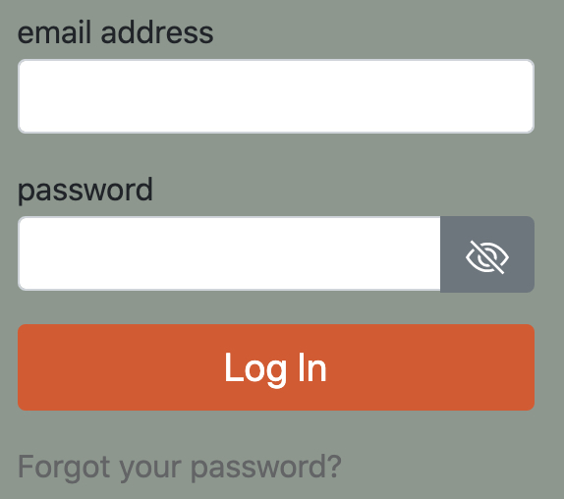  3.________________________________ |   4.________________________________
  5._______________________________ |   6.________________________________
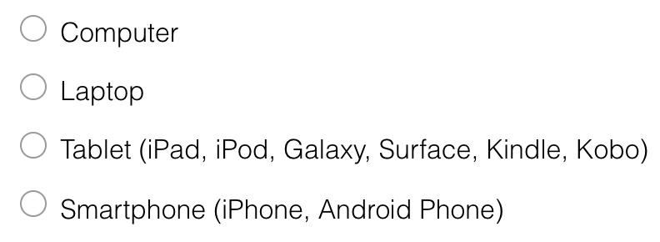  7._______________________________ | 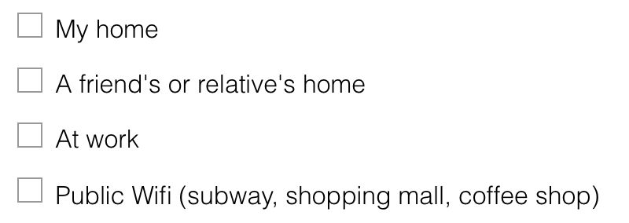  8._______________________________
  9._______________________________ |   10._______________________________

Glossary

Instructions:
- Work with a partner to review this Glossary. Classify each word as a verb or noun. Look up the meaning of any words that are new to you.
Vocabulary Word | Verb/  Noun | Meaning
App
Add a topic
Digital device
Skype
Facetime
Google Drive
Hardware
Hyperlinks
LinkedIn
Message alerts
Online Banking
Podcast
Post message/picture
Progress bar
Share photo/video
Social networking
Software
Texting
Tap on app/link

- Now use the words below to complete these sentences.

digital devices – facetime – Google Drive – hyperlink - Linkedin - message alert - podcast – progress bar

- I have a computer, a tablet and a smart phone. I have three ……………………. …………………..
- I like to make video calls with my family in my home country. It is nice to see and hear them. I really enjoy the ……………………….
- There are many kinds of social media, but on ………………………… you have to be professional. It is a site to help you network for your career.
- When I exercise I always listen to a …………………… It’s like a recorded radio show.
- When you complete a form online, the ………………… ………………. shows how much you’ve already done.
- If you want to access your files from a different computer, you can store them in an online service, such as ……………………….. …………………..
- When someone has sent me a text, my phone gives me a ………………….. …………… so I know there is a new message.
- When you see a word that is blue and underlined, it means you can click it and a new page will open. A ………………………. is a quick way to lead you to the right page.

- Finally, write five sentences with any unused words. You may combine several words into one sentence.

Using Technology and the Internet

Instructions:
In groups of 4-5 you are going to discuss your experiences with technology. In your group assign a time keeper, note taker and chair person. The chair person chooses a question from the list below that they would like to discuss. Talk about this topic for 5-10 minutes. (Follow your teacher’s instructions.) The note taker records the main discussion points.
After 5-10 minutes, switch roles. The new chair person chooses another question to talk about.
After everyone has had the opportunity to be the chair person, complete a Self Assessment for participating in the discussion to get a Skill Using Artefact.

- What do you use a computer, laptop, tablet, or smartphone for? What are some things that you can do?
- How do you use the computer to learn English? What programs do you use? What websites do you go to?
- Have you applied for a job, for school, or for services online before? Did you have to complete a form online?
- How does technology help you to build a network and to settle in your new community? How does it help you to learn about Canada?
- How does technology help you to connect with the culture and other people from your home country? Does it help you to stay in touch with people who are still in your first country?
Learning English with Technology |  | SU Speaking
Theme: Education |  |  | CLB Level: 5
Topic: Using Technology | Competency: Sharing Information / Interacting with Others

Name: ________________________________ | Date: ___________________

Student Self Assessment / Peer Assessment
As chair person | Yes | No
I opened and closed the discussion appropriately
I asked relevant questions.
I repeated information to clarify and confirm understanding
I thanked others for their contributions.
Participating in the discussion
I expressed my opinion
I provided necessary information
I agreed and disagreed appropriately
Overall
I used some variety of grammatical structures, with good control of simple structures
I participated in the discussion with some support from others
I spoke somewhat fluent
I used appropriate expressions.
I used appropriate intonation.
I used a range of common vocabulary.

TEACHER COMMENTS
Continue: | Next Time:

Learning English with Technology Survey

What do you think about using technology to learn English?

We want to learn from you to improve Avenue and the LINC program. We develop learning materials for LINC teachers and students. In this activity you are going to answer an online survey. You can use a computer, laptop, tablet, or smartphone to complete this survey. Take all the time you need to complete the activity. This is not a test, it's a learning activity.

Follow this link https://www.surveymonkey.com/r/AvenueLET or scan this QR code with your smartphone to go to the survey.



If you have a question, please ask your teacher.

Using Technology and the Internet

Instructions:

In the previous activities you’ve learned some new vocabulary, discussed how you use technology and shared your feedback with LearnIT2Teach in a survey.

Now you are going to use your experience from the discussion group and answering the online survey to write an informative paragraph about different ways that you can use technology. Choose one question from Speaking Activity 4 Using Technology and the Internet to write a response to. You may use any notes you took during the discussion group or ideas you got from the online survey.

Your work should be one paragraph and have a clear main idea, some details and good concluding sentence.

Follow your teacher’s instructions for submitting your work. You may be asked to post to a forum or submit your work online.

When you are finished, ask a classmate to read and complete an evaluation checklist to receive a Skill Using artefact.

