Instructor Instructions: Enlarge and copy pictures. Post on board. Elicit vocabulary. Provide vocabulary when needed. Flashcards can be used to label the pictures for lower levels. CLB 3 and 4 can brainstorm spelling and use a dictionary to self-check.
 | laptop
 | smartphone
 | tablet
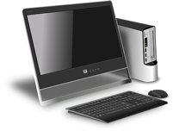 | computer

 | talking
 | gaming
 | shopping
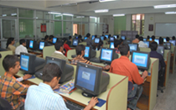 | learning
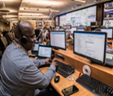 | working

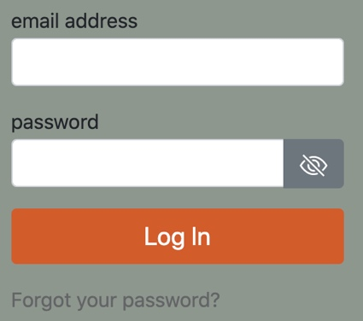 | login
 | address  bar
bread
crumbs
 | search  bar
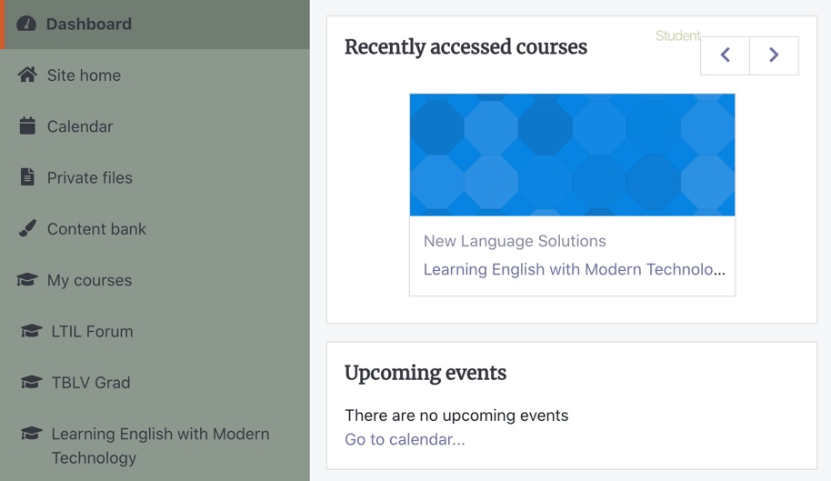 | blocks

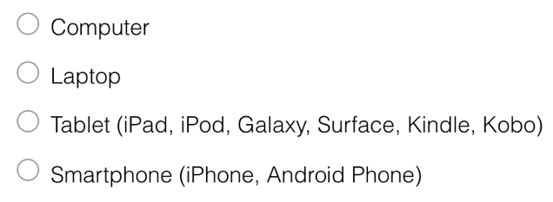 | radio  button
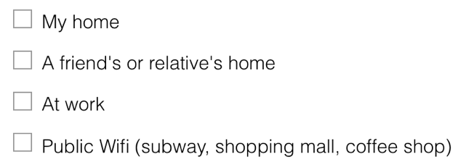 | check  box
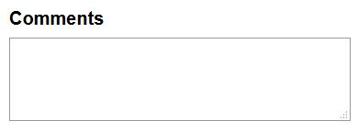 | text  box
https://www.surveymonkey.com/r/LIT2Tlearner | link
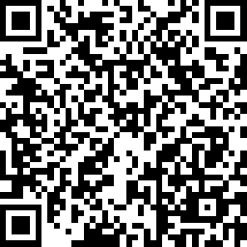 | QR code

CLB 3 and CLB 4: Ask a classmate questions. Complete the chart.
Print C for Canada, and  for 1st country.
 | study | work | shopping | family and friends | games | other
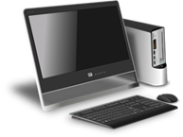



Turn the page
Ask questions. Listen to the answer and check.
Ask about  When  and  Where | study | work | shopping | family and friends | games
Morning
Afternoon
Evening
Night
Everyday
3 or 4 times a week
Once a week
Once a month
In my home
In the coffee shop
At the library
In school

Name: _____________________________ Date: ___________________

CLB 3 Write 5 sentences about using devices in your first country.
OR
Write 5 sentences about using devices in Canada.
Include what, when and how.
Check past tense and present tense verbs.
Check your spelling and punctuation.
__________________________________________________________
__________________________________________________________
__________________________________________________________
__________________________________________________________
__________________________________________________________
__________________________________________________________
__________________________________________________________
__________________________________________________________
__________________________________________________________
__________________________________________________________
Name: _____________________________ Date: ___________________
CLB 4 Write a short paragraph to describe your use of devices
in your first country OR in Canada. Include what, when and how.

Check your:
- paragraph (opening, details, closing)
- past tense and present tense verbs
- spelling and punctuation
__________________________________________________________
__________________________________________________________
__________________________________________________________
__________________________________________________________
__________________________________________________________
__________________________________________________________
__________________________________________________________
__________________________________________________________
__________________________________________________________
__________________________________________________________

CLB 3 / CLB 4
SURVEY
PARTICIPANTS WANTED

New Language Solutions is looking for
LINC students
to participate in an online survey.

We are interested in your past and current technology use.

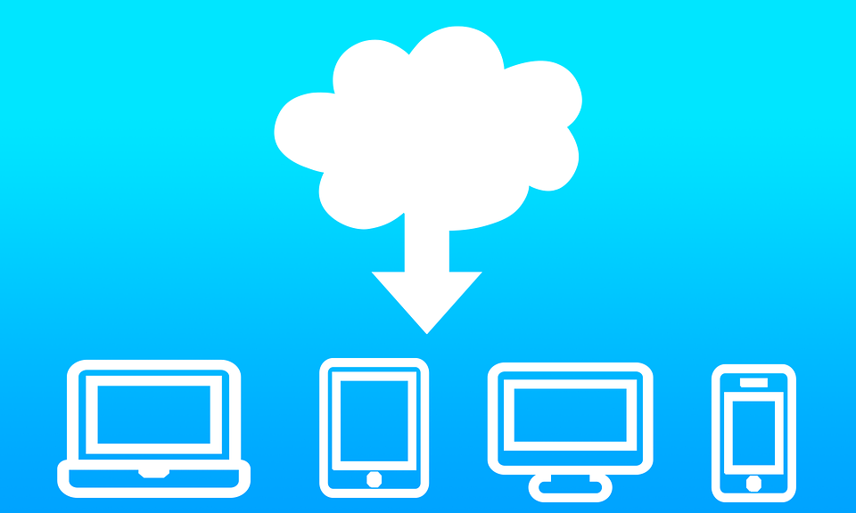

Please complete our 40-minute survey
The survey opens on September 1, 2021.

To participate, click on the link or scan the QR code: https://www.surveymonkey.com/r/AvenueLET

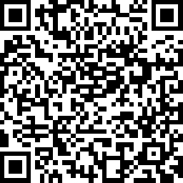

Results will be used to plan blending learning LINC classes
for students interested in studying online.
 Participants must be residents of Canada and currently attending a LINC program.

?
CLB 3 / CLB 4
Name: __________________________________ Date: ____________________

- What kind of paper is this?

________________________________________________________________

- What information is wanted?

________________________________________________________________

- Who can respond? (Who is the paper for?) (2 answers)

_______________________________________________________________

_______________________________________________________________

- When can you start the survey?

_______________________________________________________________

CLB 4
- What type of event is this for?

________________________________________________________________
- What is the purpose of the event?

_________________________________________________________________

Name: _____________________________ Date: ___________________

Instructions: CLB 3/CLB 4 Work with a partner to read the questions. Circle your answer

1. Do you use the Internet? Yes No
2. Can you access the Internet when you want? Yes No
3. Do computers and smartphones help you connect
with the culture and people in your first country? Yes No
4. Do you use the internet to meet other newcomers? Yes No
5. Do you use the Internet for learning English? Yes No
6. What websites do you use?
__________________________________________________________
__________________________________________________________
__________________________________________________________
__________________________________________________________
7. Does technology help you to learn English? Yes No
8. Have you completed online forms or surveys before? Yes No
9. Have you applied for a job, for school,
or for services online before? Yes No
10. Was it easy or difficult to apply online?
__________________________________________________________
__________________________________________________________
__________________________________________________________
__________________________________________________________

