Instructor Instructions: Enlarge and copy pictures. Post on board. Elicit vocabulary. Provide vocabulary when needed. Flashcards can be used to label the pictures for lower levels. Additional photos are provided for CLB 1 & CLB 2.
 | laptop
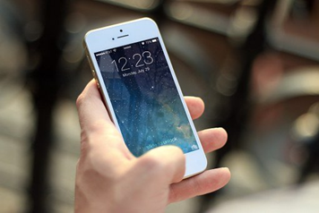 | smartphone
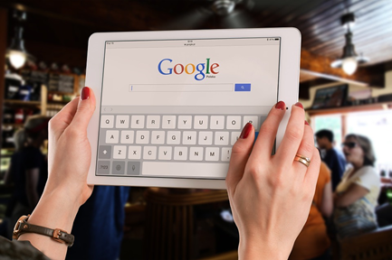 | tablet
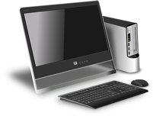 | computer
__ __ __ __ __ __
__ __ __ __ __ __ __ __ __ __

__ __ __ __ __ __
__ __ __ __ __ __ __ __

CLB 1 / CLB 2 Copy the words.

 | talking
 | gaming
 | shopping
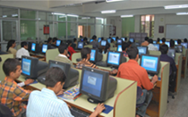 | learning
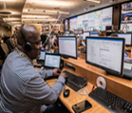 | working
CLB 1 / CLB 2 Copy the words.
__ __ __ __ __ __ __

__ __ __ __ __ __

__ __ __ __ __ __ __ __

__ __ __ __ __ __ __ __

__ __ __ __ __ __ __

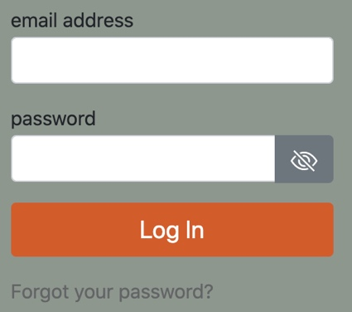 | login
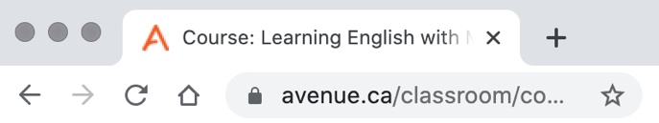 | address  bar
bread
crumbs
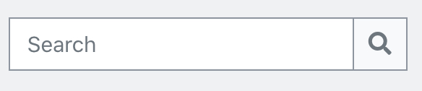 | search  bar
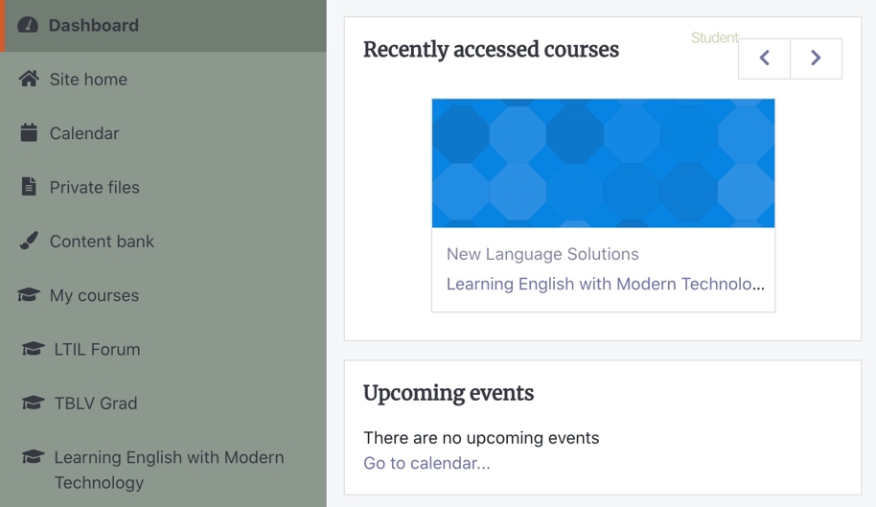 | blocks

CLB 1 / CLB 2 Copy the words.
__ __ __ __ __

__ __ __ __ __ __ __

__ __ __

__ __ __ __ __

__ __ __ __ __ __

__ __ __ __ __ __

__ __ __

__ __ __ __ __ __

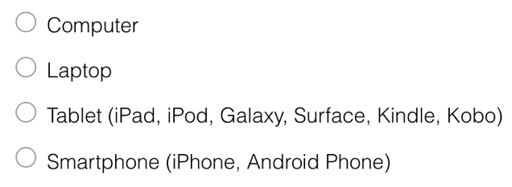 | radio  button
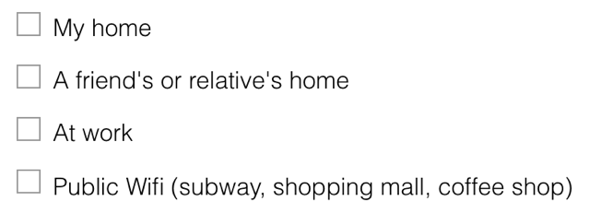 | check  box
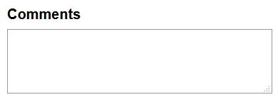 | text  box
https://www.surveymonkey.com/r/LIT2Tlearner | link
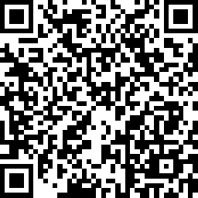 | QR code
CLB 1 / CLB 2 Copy the words.
__ __ __ __ __

__ __ __ __ __ __

__ __ __ __ __

__ __ __

__ __ __ __

__ __ __

https://www.surveymonkey.com/r/LIT2Tlearner | __ __ __ __
 | __ __ __ __ __ __

CLB 1: Ask a classmate questions.
Complete the chart.  Yes  No
First name: |  |  | Friend’s name:
Ask questions | In Canada  | In your country | In Canada | In your country
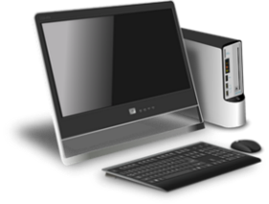


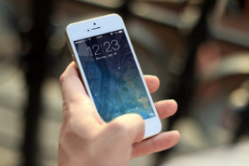

Look at the pictures. Circle the answers.
What do you do? | What does your friend do?


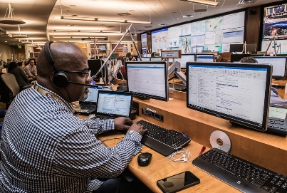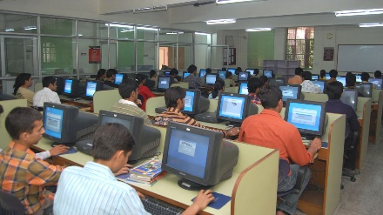



CLB 2: Ask a classmate questions. Complete the chart. Yes No
Ask questions |  | 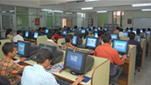 |  |  |  | 
 | 
Your
country
 | 
Your
country
 | 
Your
country
 | 
Your
country

Name: _________________________ Date: ___________________

CLB 1 Complete the sentences.
use  a | 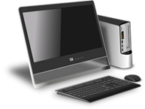  computer laptop tablet smartphone
use  for | 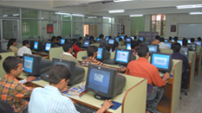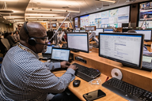  talking gaming shopping learning working

- I am from __________________________________________.
- I used a ____________________________________________.
- I used it for ________________________________________.
- In Canada, I use a _________________________________.
- I use it for __________________________________________.

Name: ________________________ Date: ___________________
CLB 2 Answer the questions. Print sentences.
- What devices did you use in your first country?
____________________________________________________________
____________________________________________________________
- What did you use it (them) for?
_____________________________________________________________
_____________________________________________________________
- When did you use it?
_____________________________________________________________
_____________________________________________________________
- What devices do you have in Canada?
_____________________________________________________________
_____________________________________________________________
- What do you use it for?
_____________________________________________________________
_____________________________________________________________
- When do you use it?
____________________________________________________________

clb 1 /clb 2

Are YOU a LINC student?

Do you use a digital device?

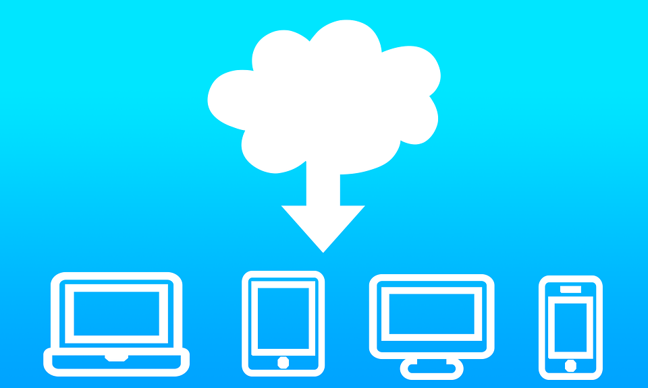

The survey takes 40 minutes to complete.

The survey is open on September 1, 2021.

To participate, click on the link or scan the QR code: https://www.surveymonkey.com/r/AvenueLET

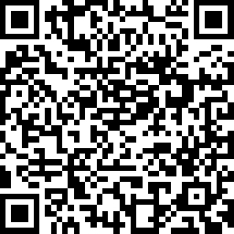

 Participants must be residents of Canada.
?

CLB 1 / CLB 2
Name ___________________________ Date___________________

Circle the answer.

- What is the start date?

September 1, 2021 October 1, 2021 September 31, 2021

- How long is the survey?

31 days 1 hour 40 minutes

- Where is the survey?

Canada Ontario Ottawa

CLB 2
Print an answer.

- What is this paper? ______________________________

- What is the survey about? ___________________________

Name: _____________________________ Date: ___________________

Instructions: CLB 1/CLB 2
Work with a partner to read the questions. Circle your answer

1. Do you use the Internet? Yes No
2. Can you access the Internet when you want? Yes No
3. Do computers and smartphones help you connect
with the culture and people in your first country? Yes No
4. Do you use the internet to meet other newcomers? Yes No
5. Do you use the Internet for learning English? Yes No
7. Does technology help you to learn English? Yes No
8. Have you completed online forms or surveys before? Yes No
9. Have you applied for a job, for school,
or for services online before? Yes No

